## Module: EGT307 AI Application Development

Practical 2: Linux

Linux is an operating system, much like Microsoft Windows or Apple Mac OS. Linux is made freely available and Open Source. Different distributions of Linux exist because different people have different opinions on what is more important.

Ubuntu - Most recommended desktop operating system.

Linux users often perform commands using the CLI, and not through a GUI.

**WSL2**

Windows Subsystem for Linux (WSL or WSL2) is a feature of Windows that allows you to run a Linux environment on your Windows machine, without the need for a separate virtual machine or dual booting. It’s designed to provide a seamless and productive experience for developers who want to use both Windows and Linux simultaneously.

Prerequisites

Windows 10 version 2004 and higher (Build 19041 and higher) or Windows 11.  
To check your Windows version and build number, select Windows logo key + R, type winver, select OK. You can update to the latest Windows version by selecting Start > Settings > Windows Update > Check for updates.

Activity 1: Installing WSL2

1. Click on ‘Start‘, search for ‘Turn Windows features on or off‘ –> Open.

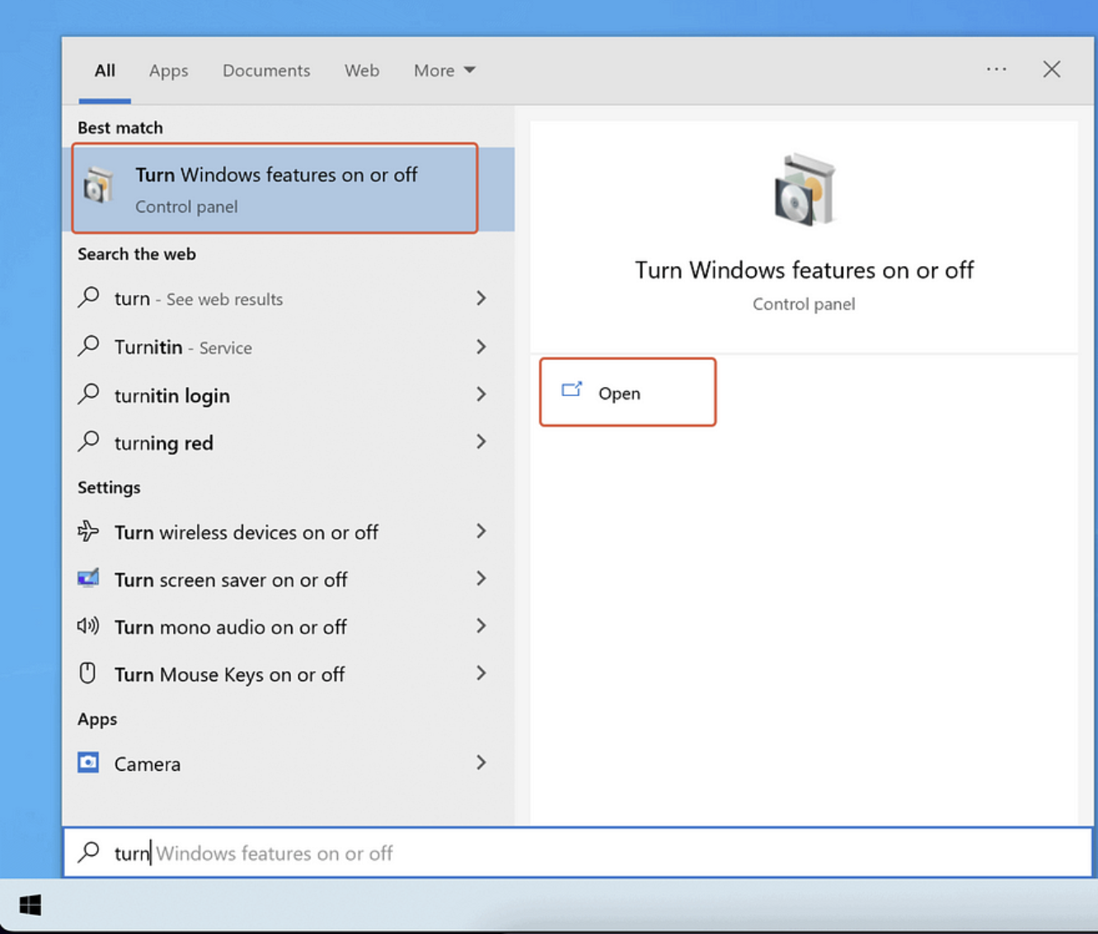

1. Enable ‘Virtual Machine Platform‘ and ‘Windows Subsystems for Linux‘ features by enabling check mark and click on ‘OK‘.

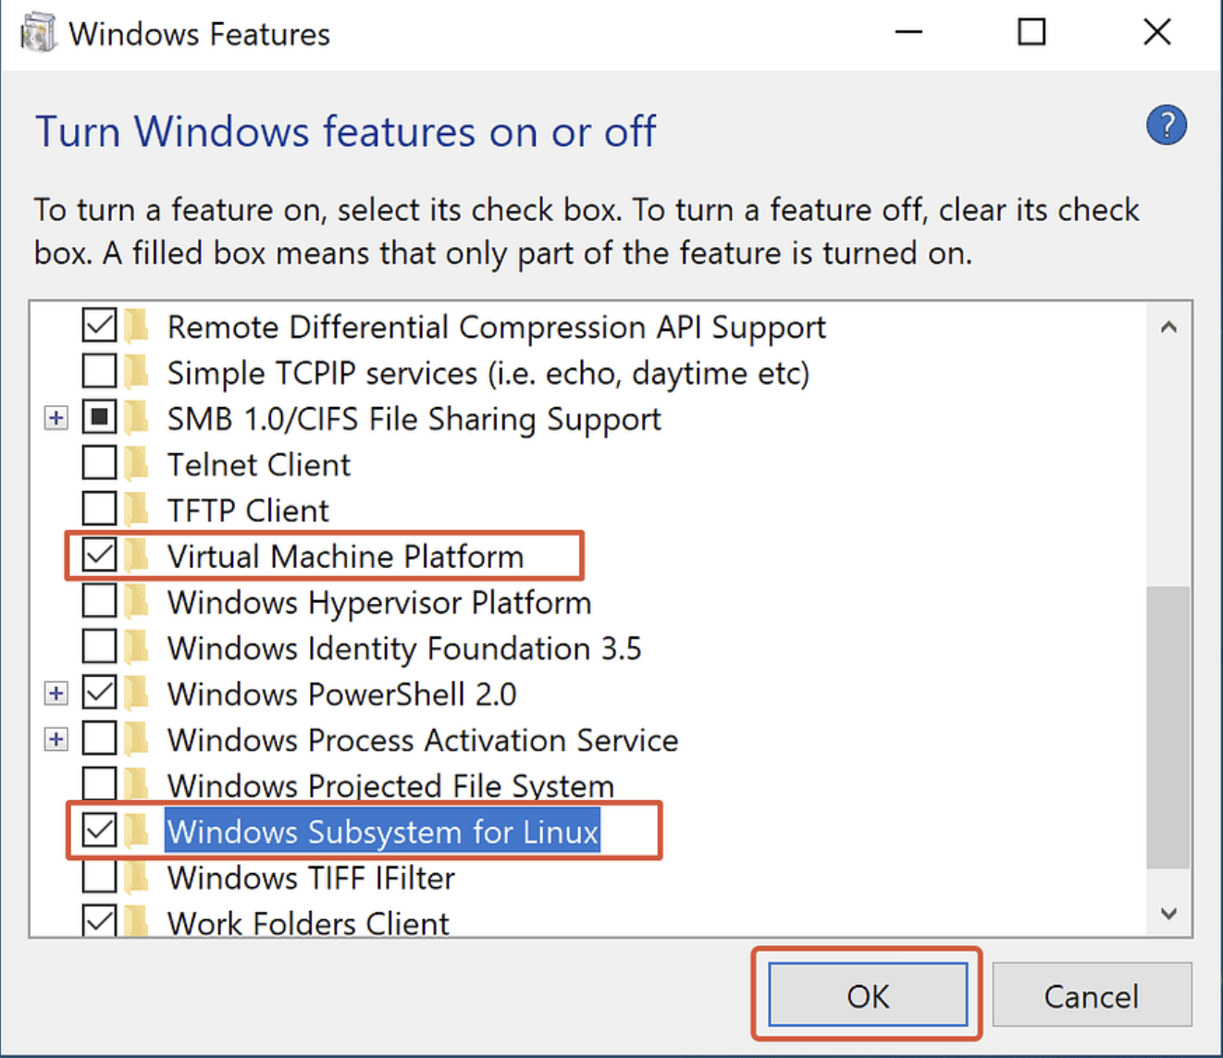

1. Restart Computer

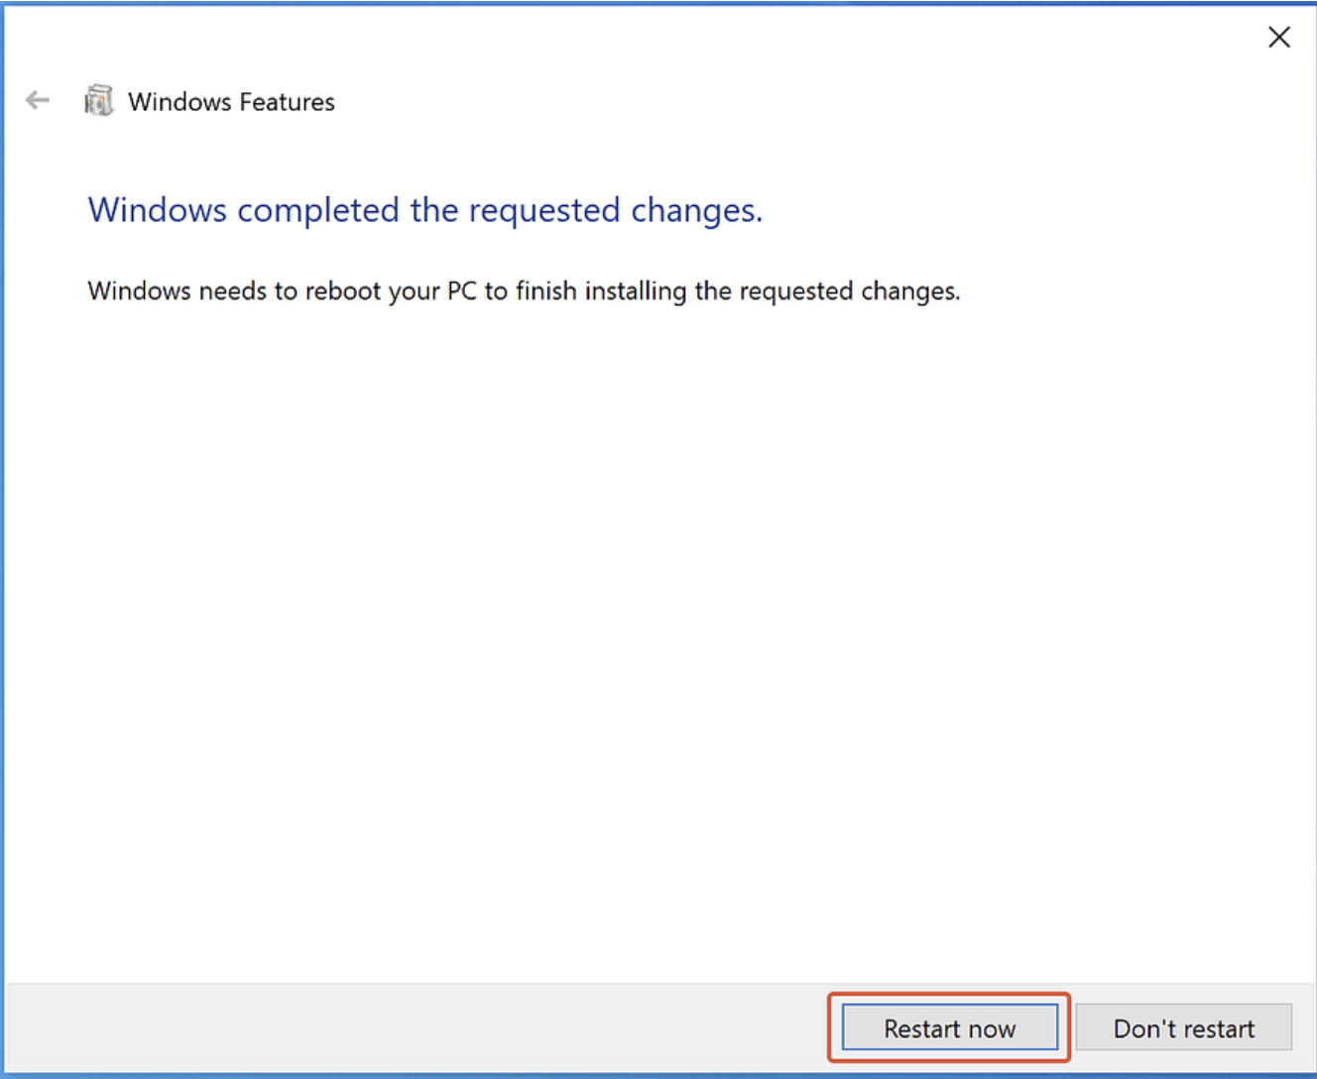

1. Install a Linux Distribution
   1. Open Microsoft Store and search for Ubuntu
   2. Select the one without numbering and click install



* 1. After successful installation, launch the installed Linux Distribution

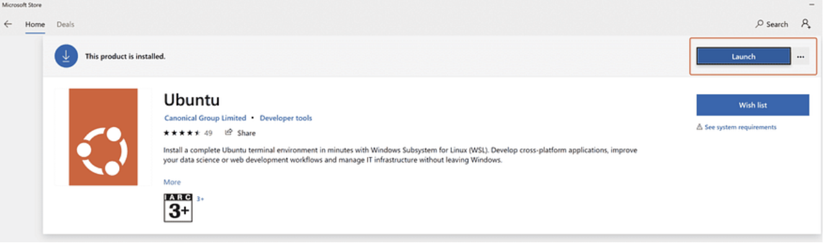

1. First time launch will take few minutes. Configure the username and password immediately after the launch of Ubuntu. Now your Ubuntu is ready to login.

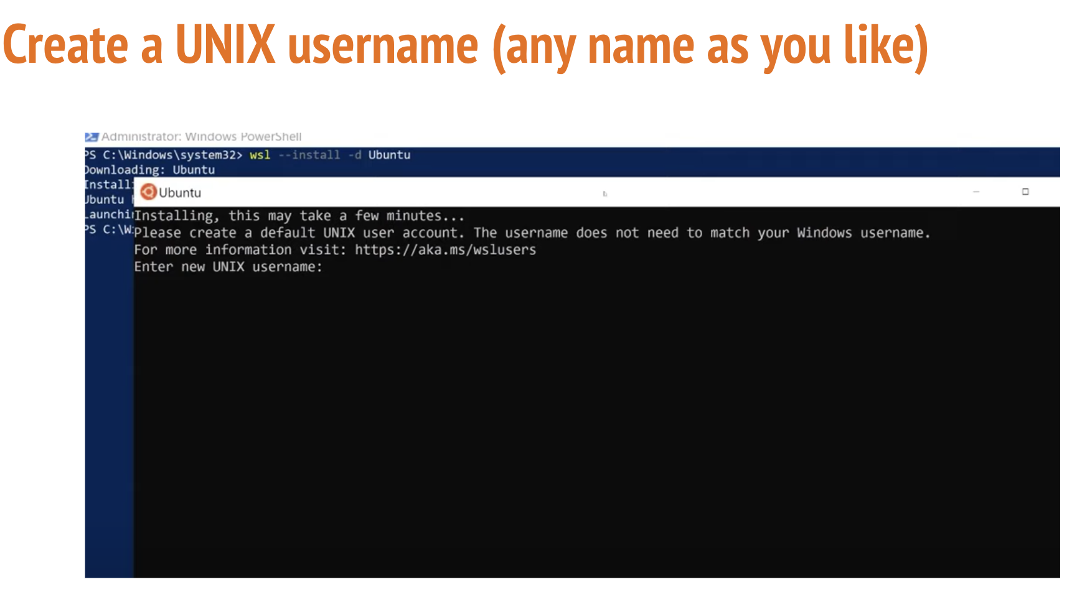

If you encounter following error, refer to Annex1.

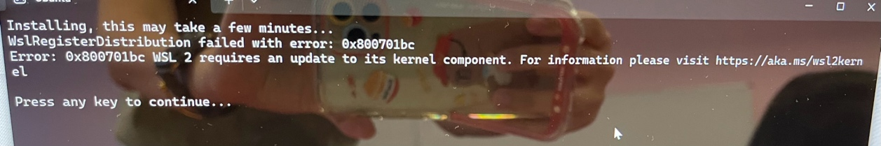

1. A successful installation looks like this:

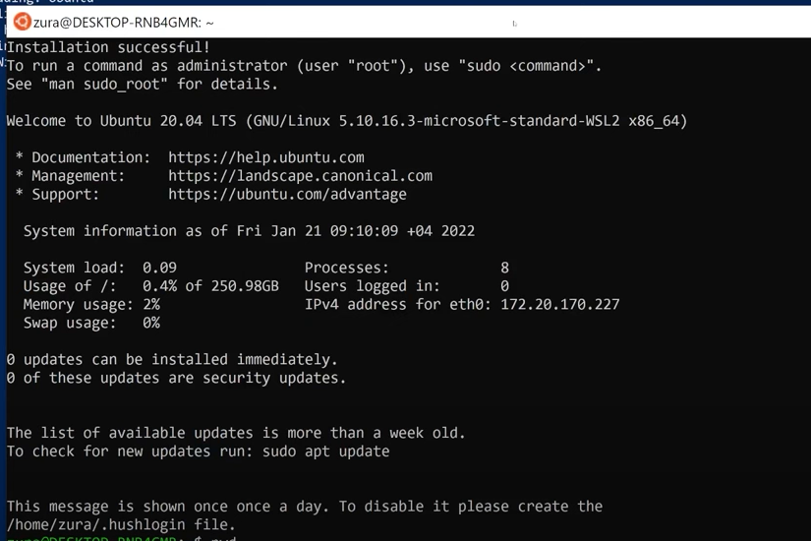

Activity2: Try it now!

In this section, you will try out a few basic Linux commands for file and directory management using WSL2. You can refer to the tables in Annex2 to choose a suitable command to achieve the following instructions.

1. List files in current working directory
2. Create a new directory named “Prac2”
3. Navigate to directory “Prac2”
4. Create a text file named “Readme.txt”
5. Edit “Readme.txt” such that it has the following content:

This is a readme file.

1. Change the permission of the text file to the following:  
   Owners: Read, Write, Execute  
   Group: Read, Write  
   Others: Read
2. Copy the file “Readme.txt” to the parent directory (i.e. one level up)
3. Navigate to the parent directory
4. Print out current working directory path
5. Remove directory “Prac2”

Activity3 (optional): Using Visual Studio Code with WSL2

Visual Studio Code, along with the WSL extension, enables you to use WSL as your full-time development environment directly from VS Code. You can:

* develop in a Linux-based environment
* easily manage your version control with VS Code's built-in Git support
* run commands and VS Code extensions directly on your WSL projects

## Install VS Code and the WSL extension on Windows (not in WSL)

Note: If you have previously installed VS Code in your PC, please check its version.   
In order to install the WSL extension, you will need the 1.35 May release version of later of VS Code.  
Go to Help -> About to check the version.

1. Visit the VS Code Install Page (<https://code.visualstudio.com/download>) and select the 32 or 64 bit installer. Install it on Windows (not in your WSL file system)
2. When prompted to **Select Additional Tasks** during installation, be sure to check the **Add to PATH** option so you can easily open a folder in WSL using the code command.
3. Install the WSL extension  
   Go to extension tab on the left, type in “wsl” and enter to search. Click install to install the extension.  
     
   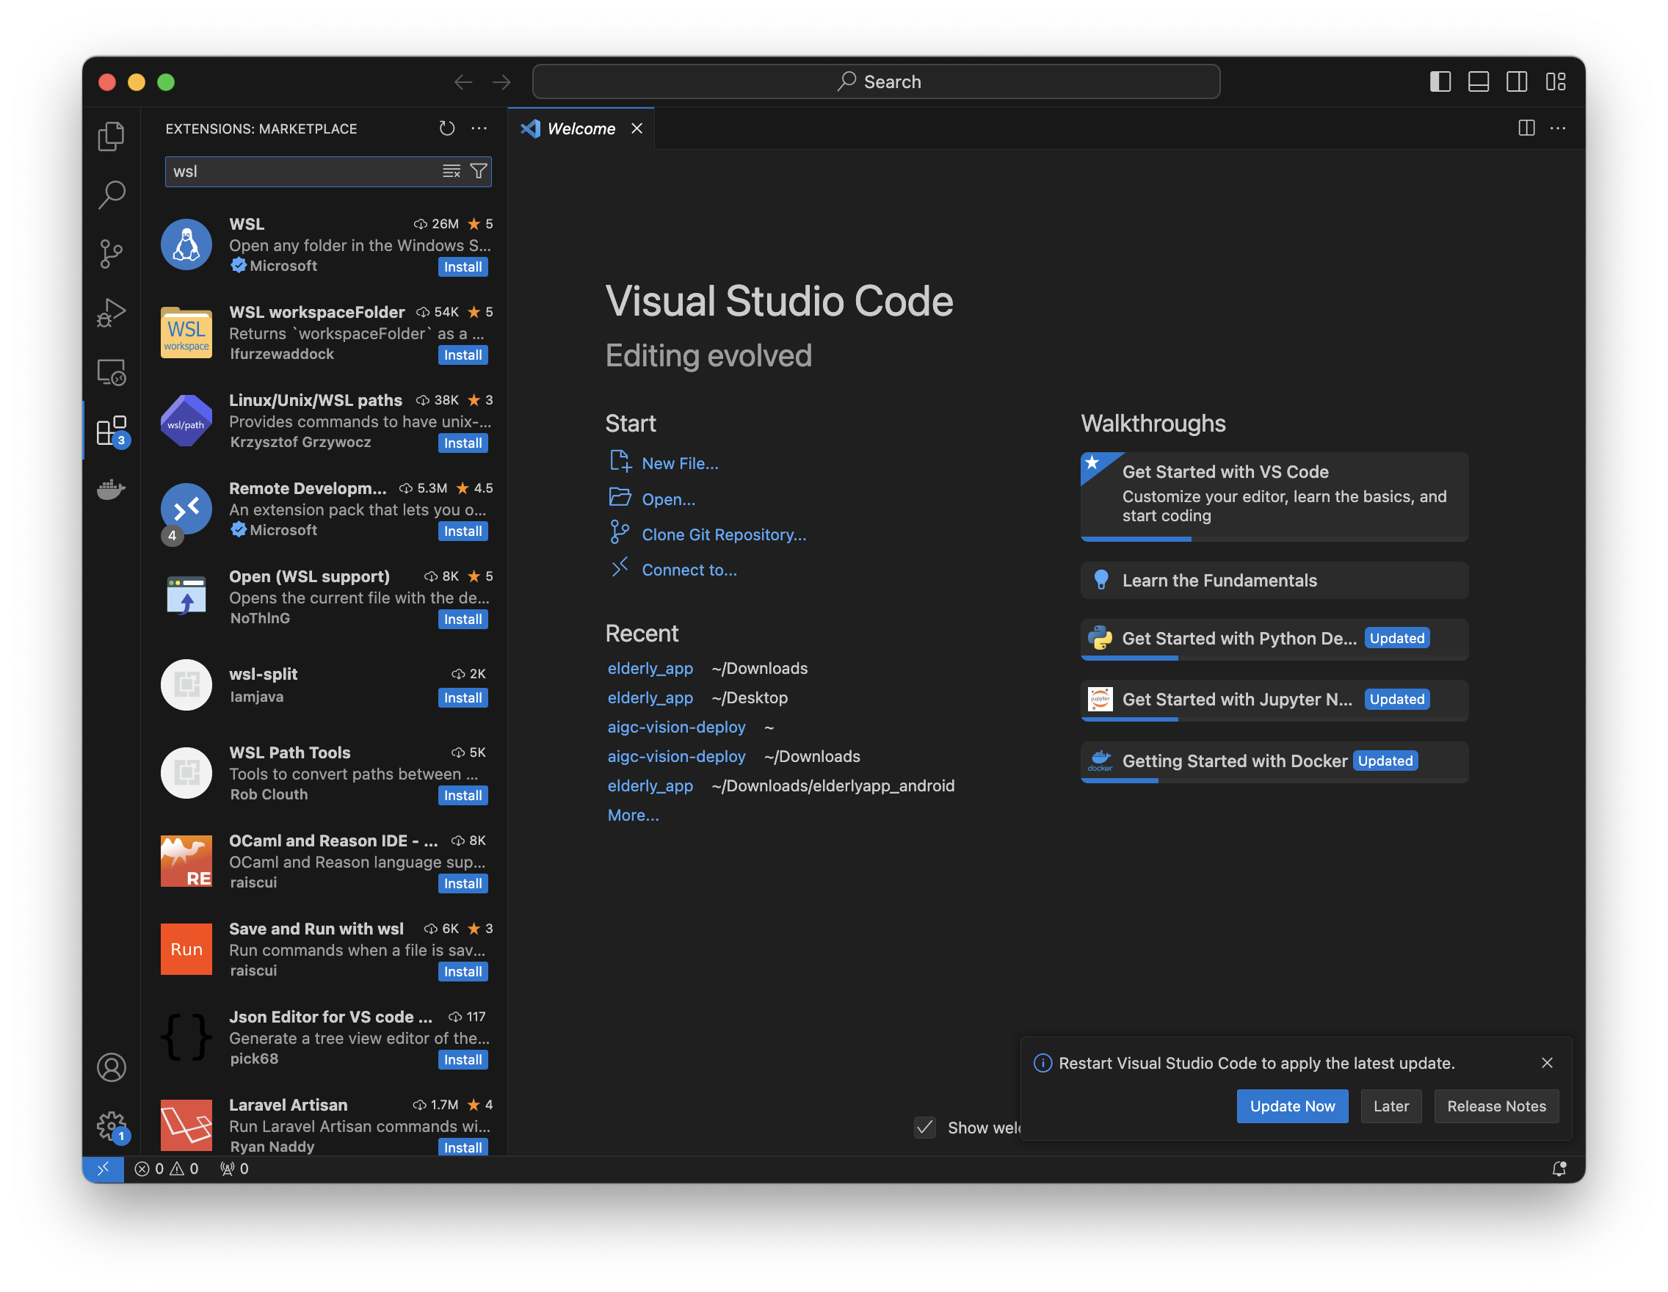

## Update your Linux distribution (in WSL)

1. Type following command in WSL command prompt to update.  
   
2. To add wget (to retrieve content from web servers) and ca-certificates (to allow SSL-based applications to check for the authenticity of SSL connections), enter:



Type y when prompted.

## Open a WSL project in Visual Studio Code

1. From the command-line  
   To open a project from your WSL distribution, open the distribution’s command line and enter .

When doing this for the first time, you should see VS Code fetching components needed to run in WSL. This should only take a short while, and is only needed once.

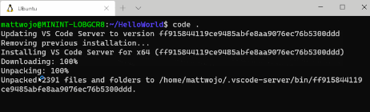  
  
*Refer to annex 3 if you get code command not found error

1. After a moment, a new VS Code window will appear, and you'll see a notification that VS Code is opening the folder in WSL.  
     
   VS Code will now continue to configure itself in WSL and keep you up to date as it makes progress.
2. Once finished, you now see a WSL indicator in the bottom left corner, and you'll be able to use VS Code as you would normally!



That's it! Any VS Code operations you perform in this window will be executed in the WSL environment, everything from editing and file operations, to debugging, using terminals, and more.

Annex1

Go to <https://aka.ms/wsl2kernel> to download the package and double click to install it.

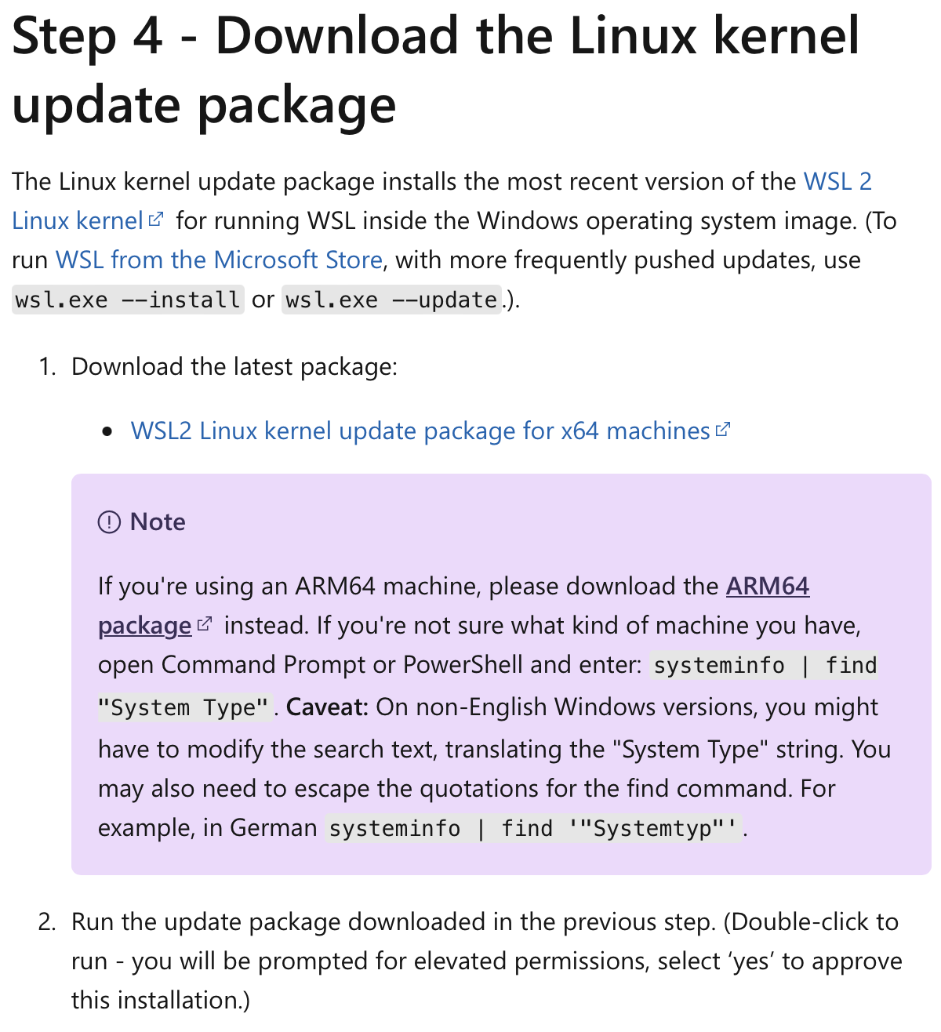

Annex2

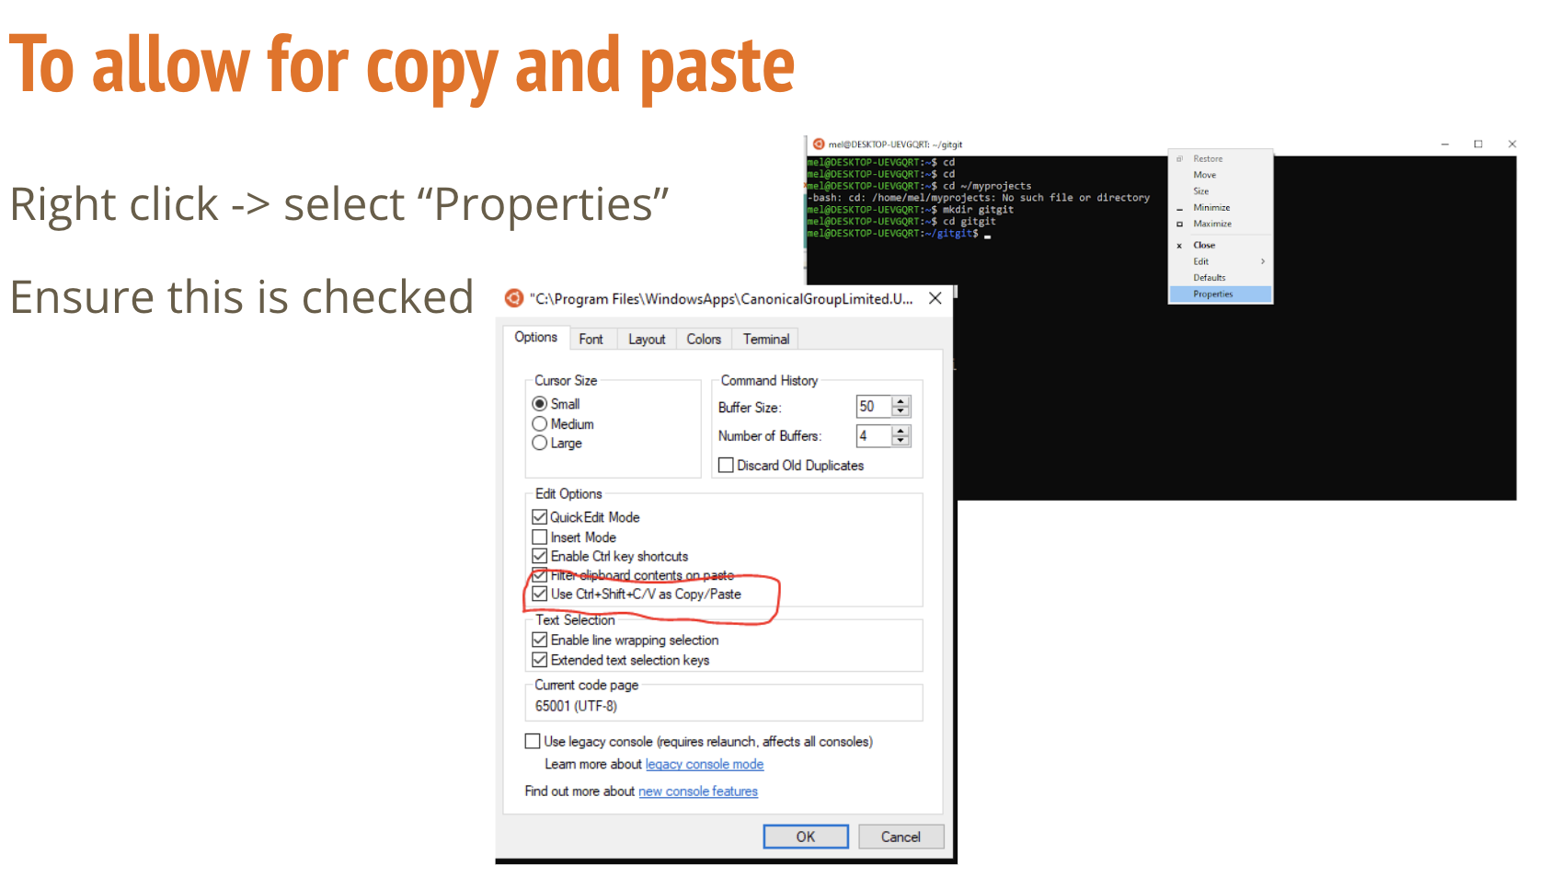

# Basic Linux commands:

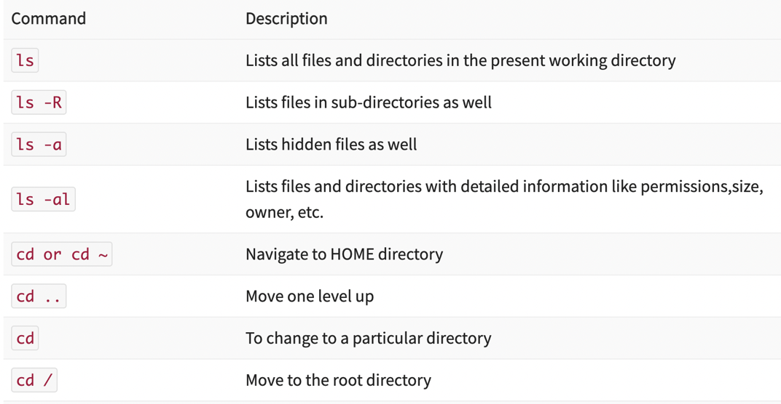

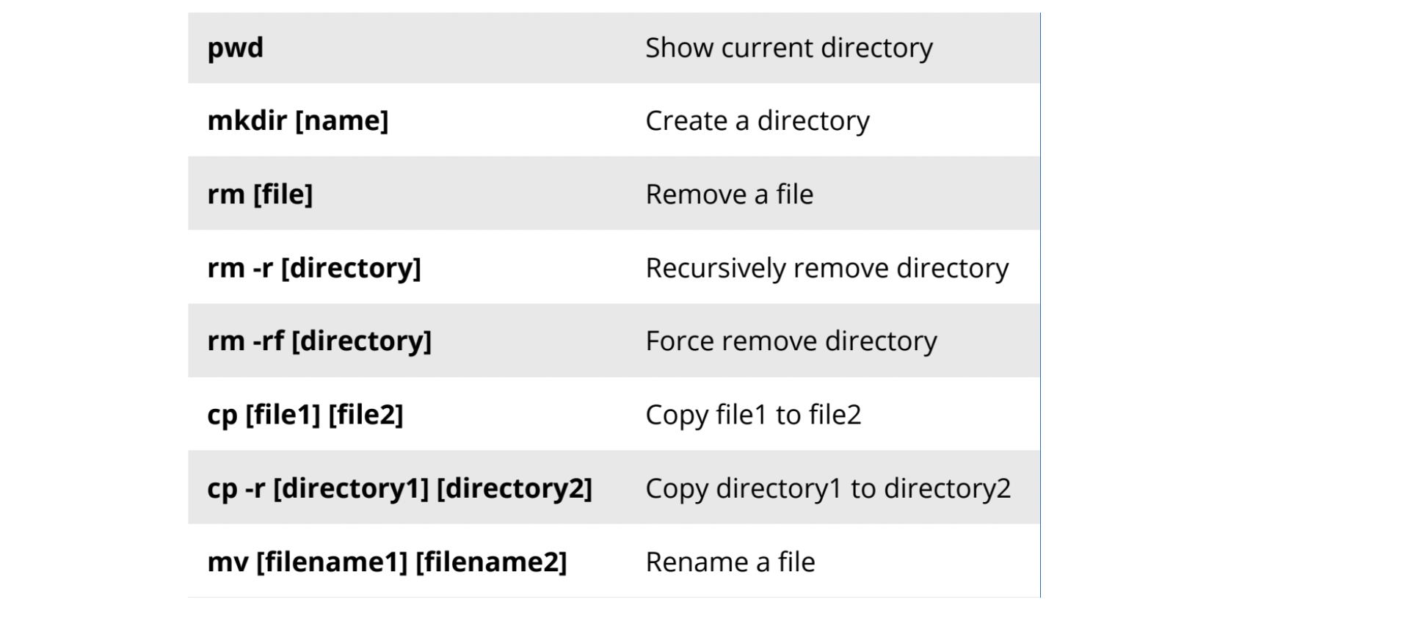

touch [filename] Create a file  
cp [filename] [directory] Copy file to directory

# Environment Variable Commands:

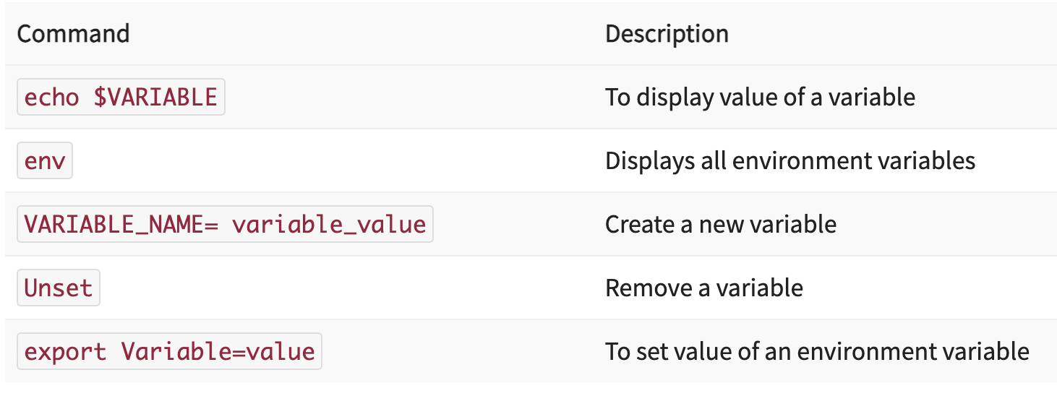

Networking Commands:

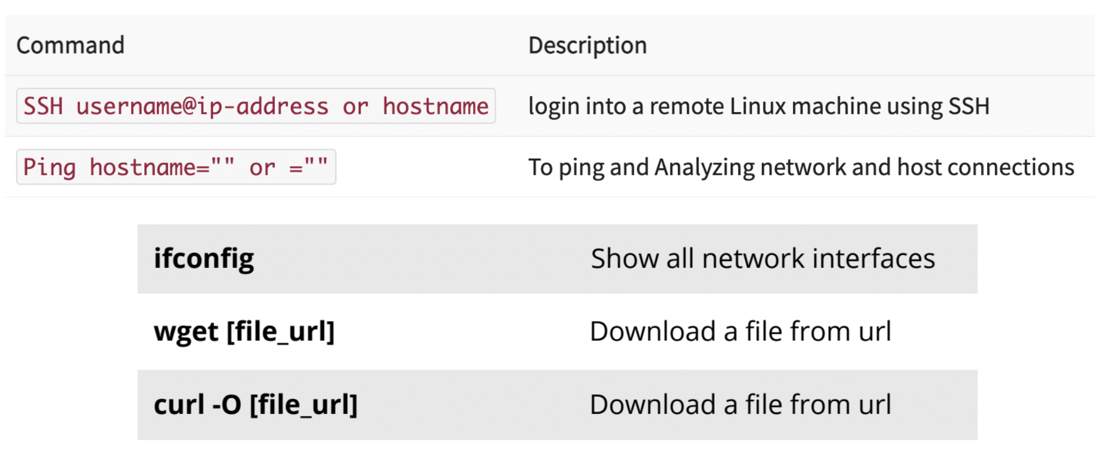

Process Commands:

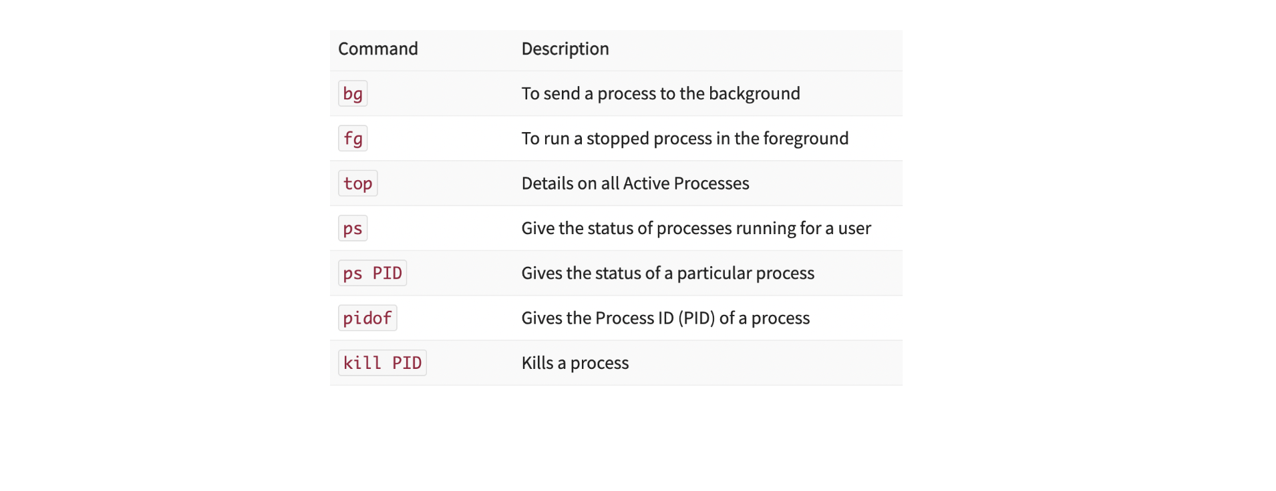

Disk Usage Commands:

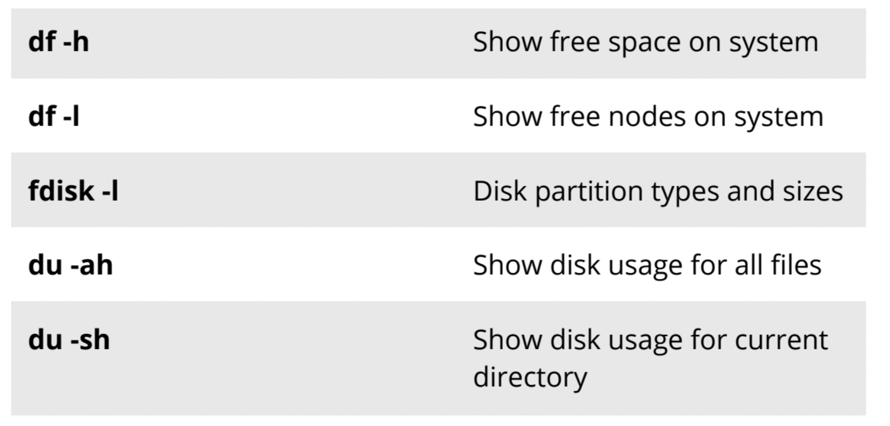

File Compression Commands:

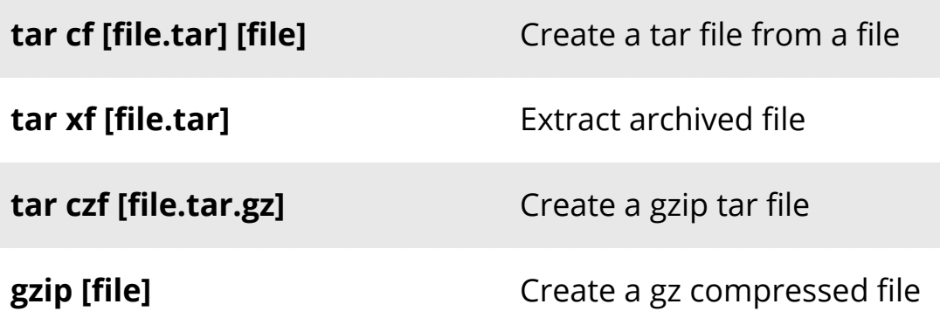

Searching commands:

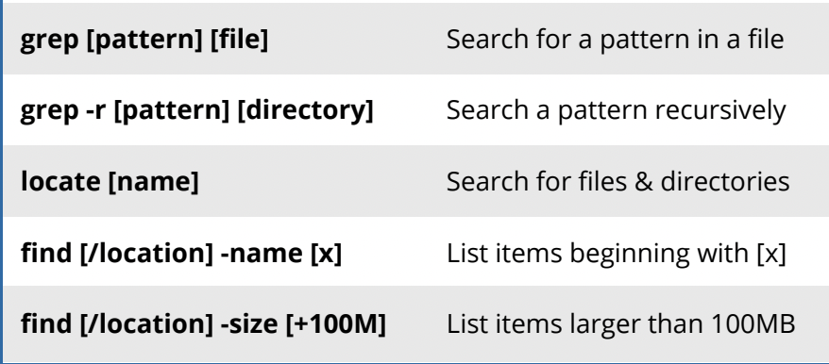

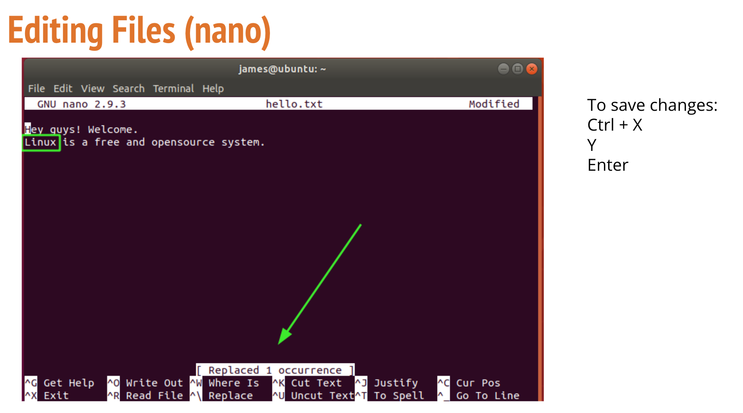

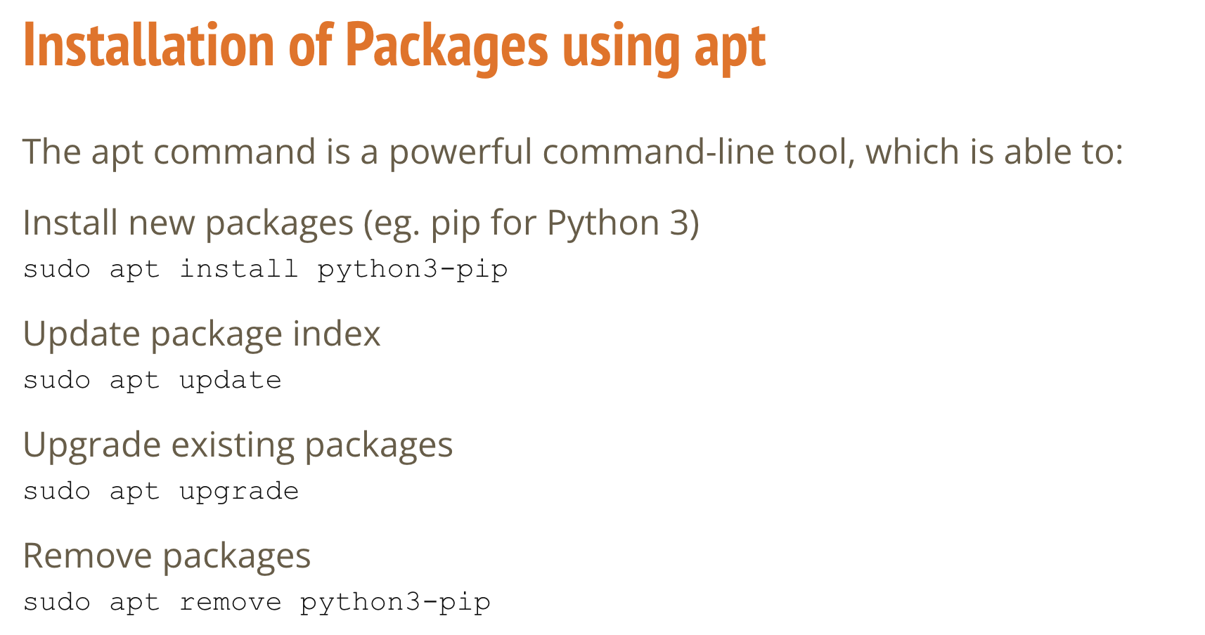

Annex3

